Lucas Madeira Maranho

76990@student.dorset-college.ie

Lecturer: [Meabh Loughman](https://moodle.dorset.ie/user/profile.php?id=3725)

Computer Science – Artificial Intelligence Basics

Group: BSC109224 A

Semester 2

Computer Science

Assignment 1

summary

1 - What is overfitting, and suggestion a mitigation strategy? What is ‘training Set’ and ‘test Set’ in a Machine Learning Model? How much data will you allocate for your Training, Validation, and Test sets? 2

2 - Draw two rough graphs showing a) overfitting and b) underfitting. 3

3 - Give an example on a method used to mitigate against overfitting? 3

4 - What is a perceptron? 3

5 - What is Neural Network? 3

6 - What is Deep Learning? 4

7 - What are the differences between Machine Learning and Deep Learning? 4

8 - Give an example of a machine learning algorithm. 4

9 - Give an example of a neural network algorithm. 5

10 - Give an example of an ethical consideration of a facial recognition neural 6

11 - REFERENCES: 7

# 1) What is overfitting, and suggestion a mitigation strategy? What is ‘training Set’ and ‘test Set’ in a Machine Learning Model? How much data will you allocate for your Training, Validation, and Test sets?

Answer:

Overfitting is when a machine learning model works too well in a training data, however its poorly on unseen data. It memorizes noise instead of learning general patterns.

Overfitting can be avoided in machine learning, using combinations of techniques, for example:

Regularization: adds penalty terms to the loss function avoiding model from fitting the training data closely.

Split Data: Divide the Data into distinct subsets, this guarantee that model is trained on one subset, hyperparameters are tuned on another, and performance is evaluated in a different way. In instances where 70/15//15 split, with 70% of the data going to training, 15% going to validation and 15% going to testing.

Cross Validation: Ensure more robust model evaluation, dividing your data into K subsets, this is called K-fold, where you train and validate your model K times, using different fold as the validation set and the remaining fold as the training set each time.

(GeeksforGeeks (2024) (Accessed: 28 January 2025)).

Training set: It allows the model learning from labelled data (inputs-outputs pairs)

Test Set: data set used to evaluate the model’s performance on unseen data, finding patterns in unlabelled data.

The allocation will depend on the size of dataset and the problem domain.

Common splits are:

Training Set: 70-80% of the data

Validation Set: 10-15% of the data

Test Set: 10-15% of the data

Small Dataset: 80% training, 10% validation, 10% test

Large Dataset: 70% training, 15% validation 10% test

# 2) Draw two rough graphs showing a) overfitting and b) underfitting.

Underfitting Overfitting

Stojiljković, M. (2024) *Linear regression in python*, *Real Python*. (Accessed: 28 January 2025).

# 3) Give an example on a method used to mitigate against overfitting?

Regularization: adds penalty terms to the loss function avoiding model from fitting the training data closely.

Split Data: Divide the Data into distinct subsets, this guarantee that model is trained on one subset, hyperparameters are tuned on another, and performance is evaluated in a different way. In instances where 70/15//15 split, with 70% of the data going to training, 15% going to validation and 15% going to testing.

Cross Validation: Ensure more robust model evaluation, dividing your data into K subsets, this is called K-fold, where you train and validate your model K times, using different fold as the validation set and the remaining fold as the training set each time.

(GeeksforGeeks (2024) (Accessed: 28 January 2025)).

# 4) What is a perceptron?

Perceptron is the capability of computer system to interpret data that is similar to the way humans use their senses to relate to the world around them.

# 5) What is Neural Network?

Neural Network is a method that AI uses to teach computers to process data in a way that is inspired by the human brain.

# 6) What is Deep Learning?

Deep Learning is Neural networks with multiple hidden layers, enabling hierarchical feature learning.

# 7) What are the differences between Machine Learning and Deep Learning?

Machine learning can adapt with minimal human interface while deep learning uses more advanced methods found in artificial neural networks.

# 8) Give an example of a machine learning algorithm.

The image below shows examples of machine learning algorithms:

Supervised learning

Unsupervised learning

Reinforcement learning

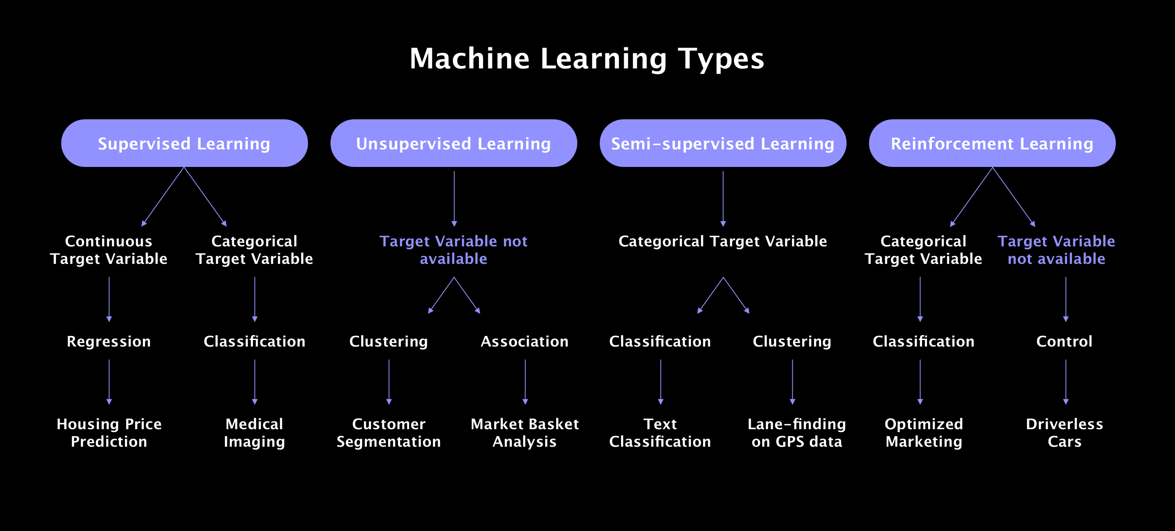

Litslink (2024) *Machine learning algorithms – A beginner’s comprehensive guide 2024*, *Litslink*. (Accessed: 28 January 2025).

# 9) Give an example of a neural network algorithm.

Inspired by the brain

Non-linear models

Deep Learning

Applications

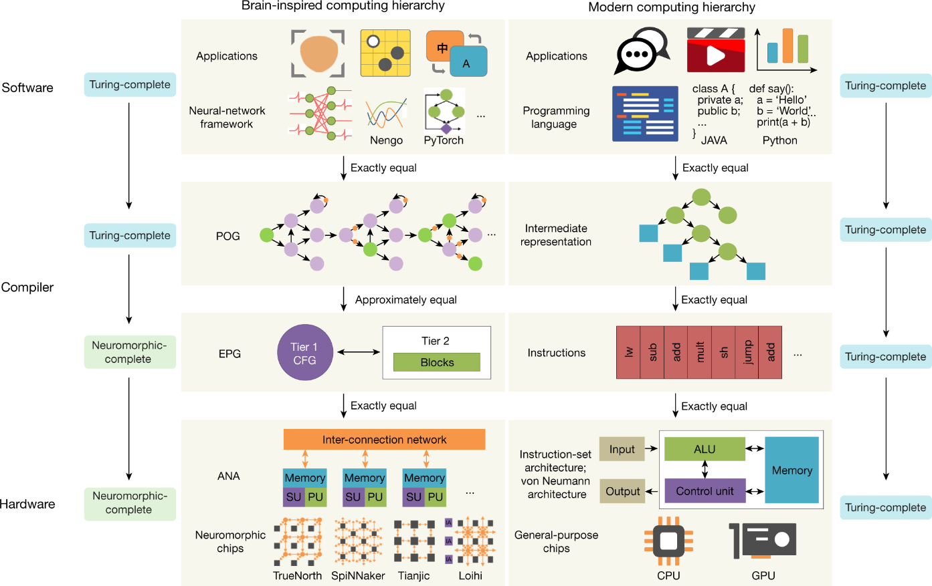

Zhang, Y. *et al.* (2020) *A system hierarchy for brain-inspired computing*, *Nature News*.

(Accessed: 28 January 2025).

# 10)Give an example of an ethical consideration of a facial recognition neural

Network

Machine Learning

Predictive AI

Artificial Narrow intelligence

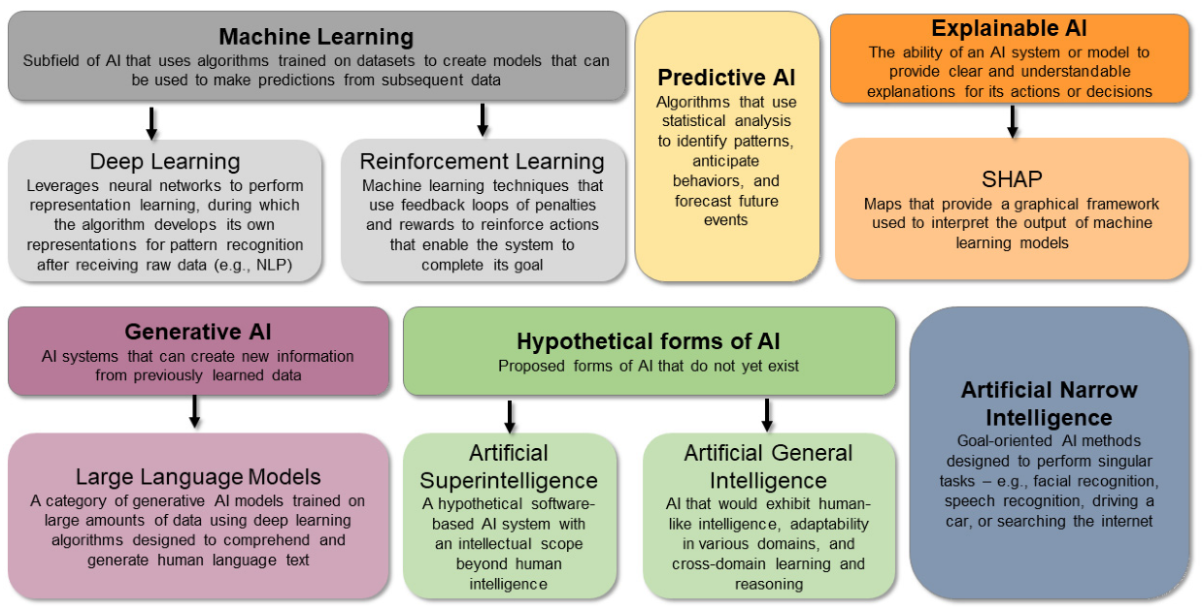

Beard, K. *et al.* (2024) *Potential applications and ethical considerations for Artificial Intelligence in traumatic brain injury management*, *MDPI*.(Accessed: 28 January 2025).

# REFERENCES:

<https://realpython.com/linear-regression-in-python>

Introduction to machine learning By Dr. Muhammad Alli

<https://litslink.com/blog/an-introduction-to-machine-learning-algorithms>

<https://www.nature.com/articles/s41586-020-2782-y>

<https://www.mdpi.com/2227-9059/12/11/2459>